May 7th, 2005
Gavin, Nadine
Well, this past week we have had two public holidays – on Monday and on Friday. Monday was May Day and Friday was Buddha’s birthday.
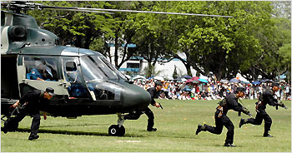
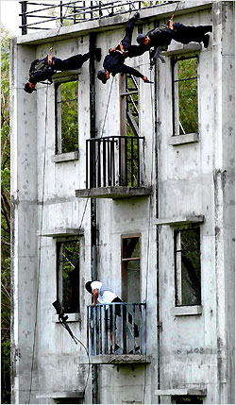
On the Monday, the PLA barracks and bases were open and some of their ships open to the public for inspection. However, it was necessary to queue up for (free) tickets several days beforehand in order to have a chance of getting in. They put on a good show. The two pictures are of this years’ show. For other pictures, go to the website:
http://english.gov.cn/2006-05/02/content_272759.htm
Again, this past week, I did not go to the gym, but instead did swimming every day. This week I swam 6.3 km, which is 1 km more than for the previous week. This coming week I may combine swimming and the gym.
You may have heard the news report that sugary fizzy drinks are to be removed from most US school vending machines. Only milk, unsweetened juice and water will be available. A good idea, as this may help to reduce obesity levels. These certainly shot up in the US when people stopped drinking milk and switched to sugary soft drinks. I remember when I was at school, there were no vending machines of course, but we used to get ½ pint of milk every morning break free. At first, I think it was compulsory but I remember later in secondary school it became voluntary but I still continued to get it. Moreover, sometimes I would drink another bottle from the extras or from people who did not have it that day. In primary school, we also used to get a free apple! Good idea! I think this was in the days when they were producing excess so instead of dumping them, they were distributed to schools.
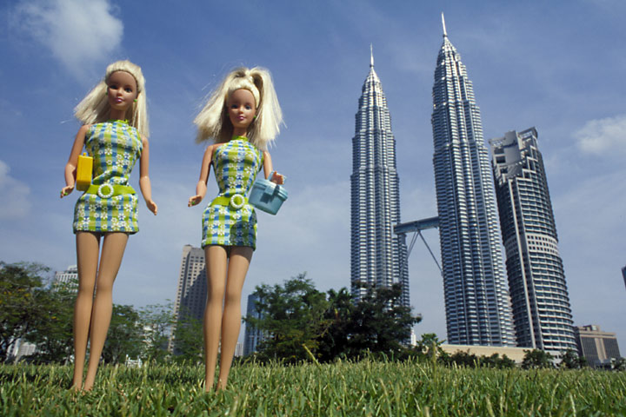
Leonie was here evening for overnight on Thursday. She flew off to Malaysia on Friday morning. Apparently, Mummy has a cheap ticket from Boston to HK via Malaysia! The picture shows twins, including the twin Petronas towers in Kuala Lumpur, which at one time were the tallest in the world. Leonie gets back on Monday.

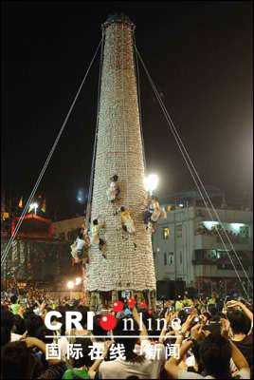
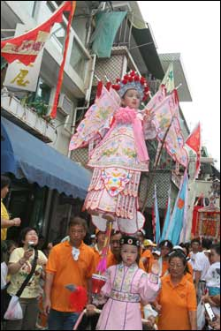
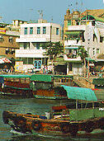
The Cheung Chau bun festival has been on. Actually, it goes on for several days. The highlight is the bun scrambling competition up the 15-metre tower, which is covered with 8000 buns, and the person to get the bun at the top is supposed to get good luck. In times past, there were several towers and it used to be a free-for-all with many people scrambling up the bamboo towers and with many falling and getting hurt. However, in 1978, the towers fell over and injured about 100 people so the government banned the towers (not the festival). The towers returned a year or two back but with very strict regulations. The towers are now made with steel frames and there is a competition to select just a few who will actually climb, and these people are attached to ropes. The pictures on the right are from this year’s festival. The climb took place at midnight on Friday. This year there was just one tower.
For other images from this year and from past years, try these websites:
http://www.bighongkong.com/bhk-photo/2004bunfestival/
http://www.cheungchau.org/
http://www.hkfastfacts.com/Chinese%20Festivals/bunFestival/BunFestival.html
That’s it for now!
Cheers

